Figuracion John Glenn F.
2A1-1/BSCS
Programming Languages
Make a c++ program
- Correct Lexical Analyzer and Wrong Syntax Analyzer
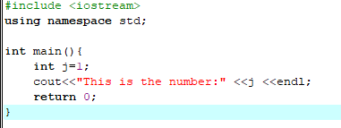
- Wrong Lexical Analyzer and Correct Syntax Analyzer
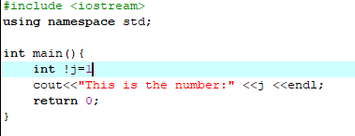
- Correct Lexical Analyzer and Correct Syntax Analyzer
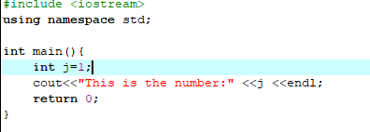

Explanation:
Program 1.it has a syntax error because of the line cout<<”This is a number:” <<j <<endl; lexically correct,but has a syntax error in cout.

Program 2. This results in a lexical error,meaning the compiler cannot recognize != in the statement int j!=1; because it expects a single assignment operator(=)instead. Has a lexical error due to != in intj!=1; but the rest is syntactically correct.

Program 3. The line int j=1; is a valid declaration and assignment of j,and cout<<”This is a number:” <<j <<endl; correctly outputs the variable j. This program fully correct and will compile and run without any issues.

